Time from symptom onset to treatment initiation and its subsequent impact on mortality in visceral leishmaniasis patients from Brazil: Analysis using the national surveillance system (SINAN), 2007-2023
Juan Sebastian Hurtado-Zapata^{,1,2,3}, Glaucia Cota⁴, James P. Wilson^{1,2}, Makoto Saito^{1,2}, Philippe J Guerin^{1,2}, Neal Alexander³, Prabin Dahal^{1,2*}
¹Infectious Diseases Data Observatory (IDDO), Oxford, UK
²Centre for Tropical Medicine and Global Health, Nuffield Department of Medicine, University of Oxford, Oxford, UK
³Centro Internacional de Entrenamiento e Investigación Médica - CIDEIM, Universidad ICESI, Cali, Colombia.
⁴Instituto René Rachou, Fiocruz Minas, Belo Horizonte, Minas Gerais, Brazil

Shorthand title: Distribution of time from symptom onset to treatment initiation

*Correspondence:
prabin.dahal@ndm.ox.ac.uk
Infectious Diseases Data Observatory (IDDO), Oxford, UK

Introduction
Visceral leishmaniasis (VL, kala-azar) is the most severe clinical form of human leishmaniasis and, if untreated, is highly lethal (1,2). It is caused by protozoa of the genus Leishmania and transmitted by infected phlebotomine sandflies (3). Clinical presentation typically includes prolonged fever, hepatosplenomegaly, pancytopenia, progressive cachexia and, in advanced cases, multiorgan failure and bleeding; immunosuppression (notably HIV coinfection) and malnutrition markedly worsen prognosis. Without adequate care and appropriate therapy, case fatality can exceed 95% within 2 years (4,5).
The disease has four primary endemic foci: the Indian sub-continent (ISC), East Africa, the Mediterranean region and Latin America (6,7). Recent World Health Organization (WHO) updates show that East Africa and Latin America now account for most of the global case burden, with the disease currently in elimination/post-elimination phase in the ISC. In Latin America, Brazil remains the most affected country and has approximately a 10% case fatality rate (8,9). This is despite free treatment available through the government healthcare system(10,11). To tackle the disease, VL was added to the country's list of notifiable diseases, and since 2007, cases in contact with the health system have been captured through the national surveillance system, the Notifiable Diseases Information System (SINAN) (12). A pseudonymised version of the database remains publicly available, and multiple nationwide and subnational analyses utilising this unique resource have addressed different epidemiological aspects of the disease (12,13). This has included characterising the spatial-temporal distribution of the disease, mapping and identifying heterogeneity in mortality across federative units, including the identification of mortality hotspots, and assessing the impact of several socio-economic indicators on the disease epidemiology (14).
One of the cornerstones of the global VL control is the timely diagnosis and treatment (15). Prolonged delay in diagnosis and treatment initiation has been associated with advanced disease progression (severe anaemia, bleeding, secondary infections, organ dysfunction), prolonged hospitalization, and increased risk of unfavourable outcomes such as treatment relapse and mortality (4,10,16). Such observations have also been identified in other major endemic regions, such as ISC. However, the exact magnitude and effect characterisation have been based on relatively small studies (15). This study aimed to address some of these gaps using Brazil’s robust national database from 2007 through 2023. The specific objectives were to:
- Characterise the distribution of gap between symptom onset to treatment initiation across different sociodemographic and clinical groups, and
- Quantify the effect of the gap between symptom onset and treatment initiation on subsequent mortality.
Findings from this analysis may provide insights to policymakers and public health professionals in Brazil towards patient management and disease control.

Methodology
Study setting and population
Brazil is a federal nation occupying approximately 8.5 million km² and with an estimated population of about 215 million in 2023. Administratively, the country is organized into five macro-regions (North, Northeast, Central-West, Southeast, and South), 26 states, the Federal District, and approximately 5,500 municipalities, each differing considerably in demographic composition, population density, and levels of urbanisation. Population distribution is highly varied: the Southeast region contains the country’s largest metropolitan areas and accounts for most of the national population, whereas the North region, which includes Amazonian territories, is characterised by low population density, large rural expanses and considerable geographic expanse (16).
Data source
Data were obtained from the publicly accessible SINAN database maintained by the Brazilian Ministry of Health via the DATASUS platform(13). Since 2007, SINAN has adopted a standardised case notification form for VL, ensuring consistency in data capture. The form includes information on the patient’s demographic, clinical, diagnostic, and treatment-related characteristics. Some of the key information captured includes patient demographics such as age, sex, race/colour and geographic location, clinical characteristics at presentation such as oedema, fever, cough, information regarding time stamps such as time of symptom onset, time when diagnosis was made, and when treatment was initiated, and date of discharge or end of the follow-up. Information is also recorded for geographical details, such as federative units and municipalities. Other patient characteristics, such as VL–HIV coinfection, details of the drug regimens used, and treatment outcomes, are also captured.
Eligibility criteria for inclusion
Records within the SINAN system captured between 2007 and 2023 were eligible for inclusion in this analysis if they satisfied the following criteria:
- VL new confirmed using molecular and/or parasitological methods,
- The date of symptom onset and the date when treatment began were both available,
- Treatment outcome was recorded.
Records were excluded when the diagnostic confirmation was based on epidemiological criteria, or when one of the critical timestamps required to calculate the primary exposure of interest was missing, or when evidence of duplication was detected across notifications. Records where there was a discrepancy between the time of symptom onset and treatment initiation, i.e., time of treatment appearing before the time of symptom onset or it was identical, were also excluded. Finally, patients considered outliers (above the 99th Percentile) in the time between symptom onset and treatment, and those with more than 365 days between treatment initiation and outcome, were excluded.
Exposure and outcome
The primary exposure variable, treatment delay, was defined as the number of days between the reported date of symptom onset (t_{s}) and the date of treatment initiation (t_{t}), calculated as the sum of the time elapsed between t_{s} and diagnosis (t_{d}) and the time between t_{d} and t_{t}. The total delay (tₛ → tₜ) was calculated as the sum of these two intervals and treated as a continuous variable. For some descriptive and graphical analyses, delay was also categorised using clinically interpretable cut-offs (<30, 30-89, 90-120, >120 days) based on the effects and prognoses of the diseases from observational studies conducted in Ethiopia, Peru, Georgia, and South Sudan(19).
Outcome definition
The primary outcome was VL-attributed mortality following treatment initiation, as recorded in the SINAN outcome field. Secondary outcomes included all-cause mortality and time to cure. For time-to-event analyses, follow-up began at the date of treatment initiation and continued for up to 365 days. Individuals were censored at the earliest occurrence of cure, death from causes other than VL, loss to follow-up, or 365 days of follow-up.
As a secondary outcome, we assessed the relationship between treatment delay and disease severity at presentation. We conducted this analysis focusing on the presence of severe clinical manifestations recorded at the time of notification. Clinical manifestations were defined a priori based on established clinical relevance and prior literature {Ref}. Three indicators: oedema, jaundice and haemorrhagic manifestations were considered markers of advanced or complicated visceral leishmaniasis. These variables were analysed individually and in combination.
Covariates and conceptual framework
Potential confounders and effect modifiers were identified a priori based on clinical relevance, existing literature, and availability across the study period. These included:
• Demographic variables: age group, sex, race/colour, education level.
• Clinical variables: presence of key signs and symptoms at notification.
• Comorbidity: HIV coinfection status.
• Treatment-related variables: initial treatment regimen.
• Temporal variables: year and period of notification.
• Geographic variables: region and federative unit.
A directed acyclic graph (DAG) was constructed to guide confounder selection and avoid inappropriate adjustment for mediators or colliders.
Statistical analyses
Continuous variables were summarised using medians and interquartile ranges (IQRs), and categorical variables using frequencies and percentages. Median delays were calculated separately for: i) Symptom onset to diagnosis ($t_{s}$ → $t_{d}$), ii) diagnosis to treatment initiation ($t_{d}$ → $t_{t}$) and iii) total delay ($t_{s }$→ $t_{t}$).
These summaries were stratified by demographic, clinical, temporal, and geographic characteristics, as well as by treatment outcome. Temporal trends were examined across four predefined periods (2007–2009, 2010–2014, 2015–2018, and 2019–2023). Finally, Geographic variation in treatment delay was visualised using choropleth maps at the federative unit level.
Factors associated with treatment delay
To identify predictors of treatment delay, linear regression models were fitted with log-transformed total delay as the dependent variable. Results were expressed as geometric mean ratios with 95% confidence intervals. Multivariable models included covariates selected a priori based on the conceptual framework and data completeness.
Evaluation of primary outcome
Survival analysis: Kaplan-Meier
The relationship between treatment delay and VL-related mortality was quantified within one year of treatment initiation using a time-to-event framework. The time origin (t₀) for survival analyses was the date of treatment initiation, and individuals were censored at cure, non-VL death, loss to follow-up or 365 days of follow-up (right-censoring). The Kaplan-Meier method was used to estimate survival, and the results were presented at different cut-offs of the primary exposure variable previously defined.
A Cox regression model was used to investigate the relationship between the primary exposure variable and mortality, employing a flexible approach to modelling the potential nonlinearity of the exposure effect. Nonlinearity in the Cox model was investigated using splines or by adopting flexible parametric/Royston-Parmar models. All covariates incorporated in descriptive and multivariable analyses, including demographic variables, clinical indicators, comorbidity status, and geographical identifiers, were selected based on predefined relevance (biological or epidemiological) and availability across the full study period.
Evaluation of secondary outcome
Composite severity categories were constructed to explore dose–response patterns between symptom burden and treatment delay: i) No severe symptoms, ii) at least one severe symptom (either oedema or haemorrhage) and iii) Both severe symptoms present (oedema and haemorrhage). By the last, a further composite indicator captured the overall symptom burden.
The association between treatment delay and severe clinical manifestations was evaluated using multivariable logistic regression. The dependent variable was the presence of severe symptoms at notification, and the primary exposure was treatment delay, modelled as a continuous variable using a restricted cubic spline to smooth its effect and distribution.
Odds ratios (ORs) and corresponding 95% confidence intervals were estimated to quantify the association between increasing delay and the probability of presenting with severe symptoms. Treatment delay was scaled to improve the interpretability of effect estimates.
Stratified and interaction analyses
According to the clinical relevance of HIV coinfection, analyses were stratified by HIV status (HIV-positive, HIV-negative). Separate models were fitted within each stratum to evaluate the association between treatment delay and severe manifestations. Effect estimates were presented graphically to facilitate comparison across strata.
Role of the funding source
The funder of the study had no role in study design, data collection, data analysis, data interpretation, or writing of the report.
Ethics
This study used pseudonymised, publicly available secondary data from the SINAN system. In accordance with Brazilian National Health Council Resolution No. 466/2012, research ethics committee approval was not required for analyses of pseudonymised public data.

Results
Results
Between 2007 and 2023, a total of VL notifications were recorded in SINAN. After applying the eligibility criteria, 35,186 individuals were included in the descriptive analyses of treatment delay. Of these, 31,177 individuals had complete outcome information and were included in survival analyses (Figure 1).
The median age was 17.5 years, but important representation of children under five years old (34%) and adults aged 16–50 years (38%). Most cases occurred in males (64%), individuals of brown race/colour (70%), and residents of the Northeast region (47%). HIV coinfection was recorded in 7.3% of cases, although HIV status was missing for 20% of notifications (Table Sxx).
Distribution of time from symptom onset to treatment initiation
Overall, the median time from symptom onset to treatment initiation (tₛ → tₜ) was 27 days (14–55). This interval was driven primarily by delays between symptom onset and diagnosis, while the median time from diagnosis to treatment initiation was 0–1 day across most subgroups.
Treatment delay from symptom onset varied substantially by age. Children under 1 year had the shortest median delay (19 days), while adults aged 16–50 years and those aged over 50 had the longest delays (35 and 34 days, respectively). Males had longer median delays than females (31 vs 24 days).
Temporal trends showed a modest yet consistent reduction in treatment delay. Median delays decreased from 31 days in 2007–2009 to 27 days in 2019–2023. Nevertheless, delays remained substantial throughout the study period.
Marked geographic heterogeneity was observed. The shortest median delays were recorded in the North (22 days), while the longest were observed in the South (54 days), though the latter accounted for only a very small proportion of cases. The Northeast region, which bore nearly half of the national burden, had a median delay of 31 days. Choropleth maps demonstrated inter-state variability across periods (Figure 2).

Factors associated with treatment delay
In multivariable linear regression models, demographics, years-period, and geographic factors were independently associated with treatment delay (Table 3).
Compared with adults aged 16–50 years, early age groups (under 16 years) had significantly shorter delays, particularly children under one year (adjusted ratio of geometric means [aRGM] 0.52, 95% CI 0.48–0.57). Male sex was associated with longer delay (aRGM 1.03, 95% CI 1.01–1.06).
Compared with the 2010–2014 reference period, treatment delays were longer in 2007–2009 and progressively shorter in subsequent periods, with the greatest reduction observed in 2019–2023 (aRGM 0.86, 95% CI 0.83–0.89). In the same way, geographic variation persisted after adjustment. Relative to the Northeast region, shorter delays were observed in the North (aRGM 0.79, 95% CI 0.77–0.82), Southeast (0.85, 95% CI 0.82–0.88), and Centre-West (0.84, 95% CI 0.80–0.88), while substantially longer delays were observed in the South (aRGM 1.45, 95% CI 1.16–1.82).
Education level showed weaker and less consistent associations after adjustment. Race/colour was associated with delay in unadjusted analyses, but these associations were not evident in multivariable models, except for individuals classified as Afro-descendants, who experienced longer delays than brown individuals (aRGM 1.09, 95% CI 1.04–1.14).
HIV coinfection was associated with longer delay in univariable analyses, but this association was no longer evident after adjustment.

VL Mortality attribute following treatment
The total number of individuals included by complete outcome data was 26,537 (85.1%), of whom 2,105 (6.8%) died due to VL, and 529 (1.7%) died from other causes. The remaining individuals were transferred, lost to follow-up, or classified as treatment abandonment.
The median time from treatment initiation to outcome was 29 days overall. Patients who died from VL did so rapidly, with a median time to death of 7 days, compared with a median time to cure of 27 days. This pattern was consistent across age groups, regions, and HIV status (Table 2).

Association between treatment delay and mortality
Kaplan–Meier analyses demonstrated a clear gradient of increasing mortality with longer treatment delays (Figure X). Individuals with longer delays experienced higher cumulative mortality within the first year following treatment initiation, reaching 7.6% at 30 days and 10% over the 150 days of follow-up.
Using treatment delay categories, a clear gradient in survival was observed (Figure xx). Individuals who initiated treatment within 30 days of symptom onset had the highest survival probability during the one-year follow-up period, with an 8% of reduction in probability at day 50 and a rate of less than 10% after day 100. Survival progressively decreased with increasing delay, with the poorest outcomes observed among those with delays ≥120 days, with values around 10.3% at day 30. Separation between survival curves occurred early and persisted over time, indicating a sustained adverse effect of prolonged delay on mortality risk. Notably, individuals with intermediate delays (30–89 and 90–119 days) showed overlapping early survival but diverged later in follow-up, suggesting a dose–response relationship between delay duration and mortality. Differences across delay categories were statistically significant based on log-rank testing (p < 0.001).
We found marked differences in VL-related survival according to HIV status (Figure X). Individuals living with HIV experienced substantially lower survival probabilities compared with HIV-negative individuals, even in the first month (7% and 12%, respectively). The divergence between curves occurred early after treatment initiation, with most excess mortality among HIV-positive patients concentrated within the first 30–60 days. The difference in survival distributions was statistically significant (log-rank test, p < 0.001).
In multivariable Cox regression models, increasing treatment delay was associated with a higher hazard of VL-related death. Flexible modelling approaches indicated a non-linear relationship, with the steepest increase in mortality risk observed at shorter delays, followed by a more gradual increase at longer delays. This association persisted after adjustment for age, sex, HIV status, geographic region, treatment regimen, and calendar period.

Severe clinical manifestations and treatment delay
Severe clinical manifestations at presentation were common and strongly associated with longer treatment delays. Oedema and haemorrhagic manifestations, analysed individually and together, were more frequently observed among individuals with prolonged delays.
In unadjusted logistic regression models, increasing treatment delay was associated with higher odds of presenting with severe symptoms. A strong relationship was observed, with the highest odds among individuals presenting with both oedema and haemorrhage compared with those without severe manifestations (Figure X).
When stratified by HIV status, the association between delay and severe manifestations was evident in both HIV-negative and HIV-positive individuals, but was more pronounced and with a rapid increment among those living with HIV. Additional analyses examining overall symptom burden showed that individuals with greater symptom burden were more likely to have experienced longer delays before treatment initiation (Supplementary Figures).

References
1. Guerin PJ, Olliaro P, Sundar S, Boelaert M, Croft SL, Desjeux P, et al. Visceral leishmaniasis: Current status of control, diagnosis, and treatment, and a proposed research and development agenda. Vol. 2, Lancet Infectious Diseases. Lancet Publishing Group; 2002. p. 494–501.
2. Geto AK, Berihun G, Berhanu L, Desye B, Daba C. Prevalence of human visceral leishmaniasis and its risk factors in Eastern Africa: a systematic review and meta-analysis. Vol. 12, Frontiers in Public Health. Frontiers Media SA; 2024.
3. Costa CHN, Chang KP, Costa DL, Cunha FVM. From Infection to Death: An Overview of the Pathogenesis of Visceral Leishmaniasis. Vol. 12, Pathogens. Multidisciplinary Digital Publishing Institute (MDPI); 2023.
4. Werneck GL, Batista MSA, Gomes JRB, Costa DL, Costa CHN. Prognostic factors for death from visceral leishmaniasis in Teresina, Brazil. Infection. 2003;31(3):174–7.
5. Abongomera C, van Henten S, Vogt F, Buyze J, Verdonck K, van Griensven J. Prognostic factors for mortality among patients with visceral leishmaniasis in East Africa: Systematic review and meta-analysis. PLoS Negl Trop Dis. 2020 May 1;14(5):1–19.
6. Wamai RG, Kahn J, McGloin J, Ziaggi G. Visceral leishmaniasis: a global overview. J Glob Health Sci [Internet]. 2020 Jun;2(1). Available from: https://doi.org/10.35500/jghs.2020.2.e3
7. José Antonio Ruiz-Postigo, Saurabh Jain, Madjou S, Virrey Agua JF, Maia-Elkhoury AN, Valadas S, et al. Global leishmaniasis surveillance, 2022: assessing trends over the past 10 years [Internet]. Geneva; 2023 Sep [cited 2025 Jul 21]. Available from: https://www.who.int/news-room/fact-sheets/detail/leishmaniasis
8. Zhang SX, Yang GB, Sun JY, Li YJ, Yang J, Wang JC, et al. Global, regional, and national burden of Visceral leishmaniasis, 1990–2021: findings from the global burden of disease study 2021. Parasites and Vectors . 2025 Dec 1;18(1).
9. Panamerican Health Organization. Manual of procedures for leishmaniasis surveillance and control in the Region of the Americas [Internet]. Washington, D.C.; 2024. Available from: https://doi.org/10.37774/9789275127346.
10. De Melo EC, Fortaleza CMCB. Challenges in the therapy of Visceral Leishmaniasis in Brazil: A public health perspective. Journal of Tropical Medicine. 2013.
11. Simão JC, Victória C, Fortaleza CMCB. Predictors of relapse of visceral leishmaniasis in inner São Paulo State, Brazil. International Journal of Infectious Diseases. 2020 Jun 1;95:44–9.
12. Cota GF, de Sousa MR, Rabello A. Predictors of Visceral Leishmaniasis Relapse in HIV-Infected Patients: A Systematic Review. PLoS Negl Trop Dis [Internet]. 2011 Jun 7;5(6):e1153-. Available from: https://doi.org/10.1371/journal.pntd.0001153
13. Ministry of Health. National surveillance database of notifiable diseases in Brazil. 2024 [cited 2026 Jan 26]. p. 1–1 Sistema de Informação de Agravos de Notificação (SINAN). Available from: https://datasus.saude.gov.br
14. Martins-Melo FR, Lima M da S, Ramos Jr AN, Alencar CH, Heukelbach J. Mortality and Case Fatality Due to Visceral Leishmaniasis in Brazil: A Nationwide Analysis of Epidemiology, Trends and Spatial Patterns. PLoS One [Internet]. 2014 Apr 3;9(4):e93770-. Available from: https://doi.org/10.1371/journal.pone.0093770
15. Scarpini S, Dondi A, Totaro C, Biagi C, Melchionda F, Zama D, et al. Visceral Leishmaniasis: Epidemiology, Diagnosis, and Treatment Regimens in Different Geographical Areas with a Focus on Pediatrics. Vol. 10, Microorganisms. MDPI; 2022.
16. Wilson JP, Chowdhury F, Hassan S, Harriss EP, Alves F, Musa A, et al. Prognostic Models Predicting Clinical Outcomes in Patients Diagnosed with Visceral Leishmaniasis: A Systematic Review [Internet]. 2024. Available from: http://medrxiv.org/lookup/doi/10.1101/2024.03.20.24304622
17. Maia-Elkhoury ANS, Romero GAS, Valadas SYOB, Sousa-Gomes ML, Lauletta Lindoso JA, Cupolillo E, et al. Premature deaths by visceral leishmaniasis in Brazil investigated through a cohort study: A challenging opportunity? PLoS Negl Trop Dis. 2019 Dec 19;13(12).
18. Diegoli H, Makdisse M, Magalhães P, Gray M. The atlas of variation in healthcare Brazil: remarkable findings from a middle-income country. Research in Health Services & Regions. 2023 Feb 8;2(1).
19. Welay GM, Alene KA, Dachew BA. Visceral leishmaniasis treatment outcome and its determinants in northwest Ethiopia. Epidemiol Health. 2016;39:e2017001.

Figures and Tables
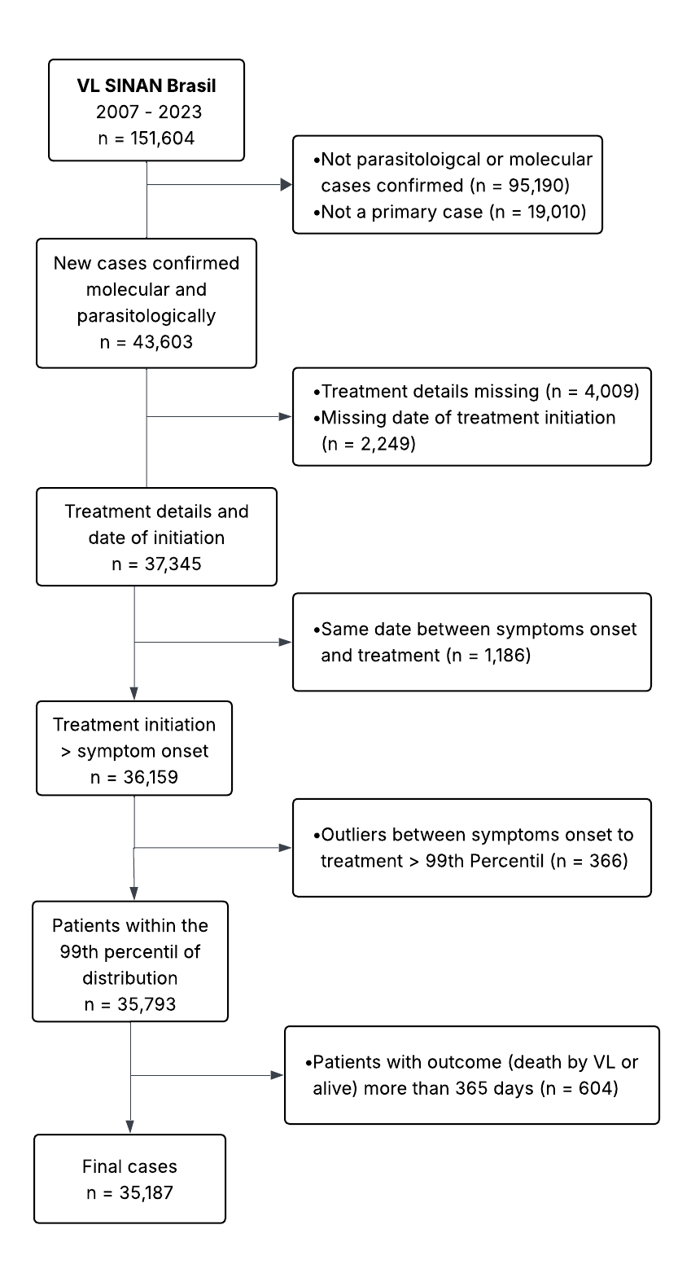
Figure 1. Patient flow diagram
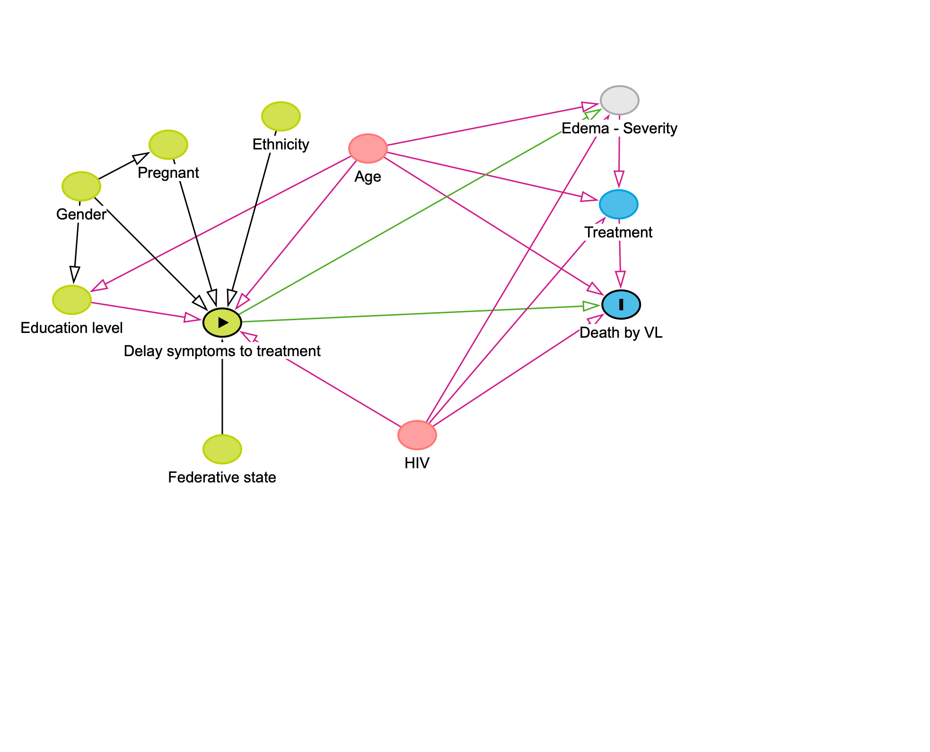Figure 2. Direct Acyclic Graph, evaluation of the variable of interest and potential
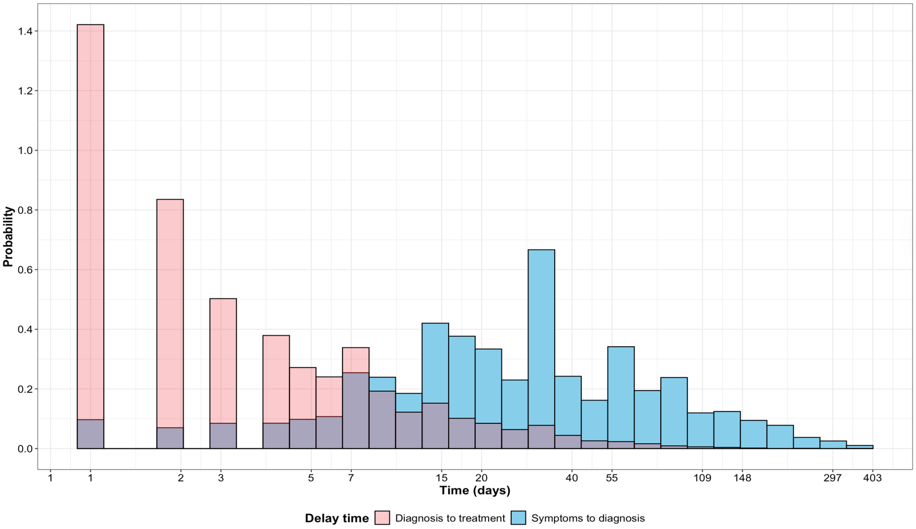
Figure 3. Delay distribution between symptom onset and diagnosis, and diagnosis to treatment initiation
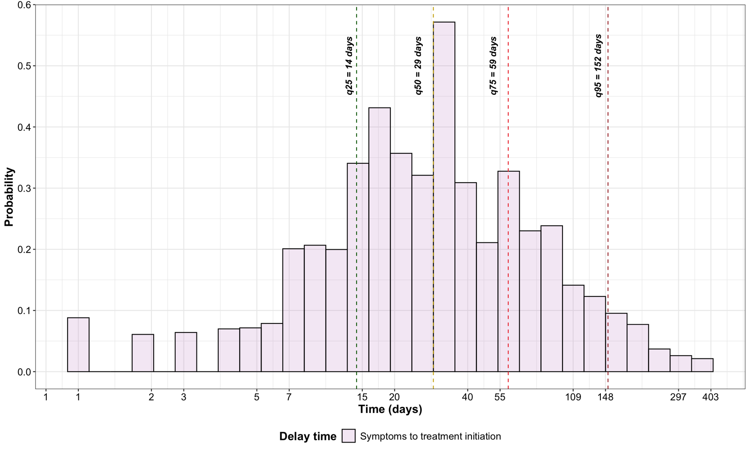

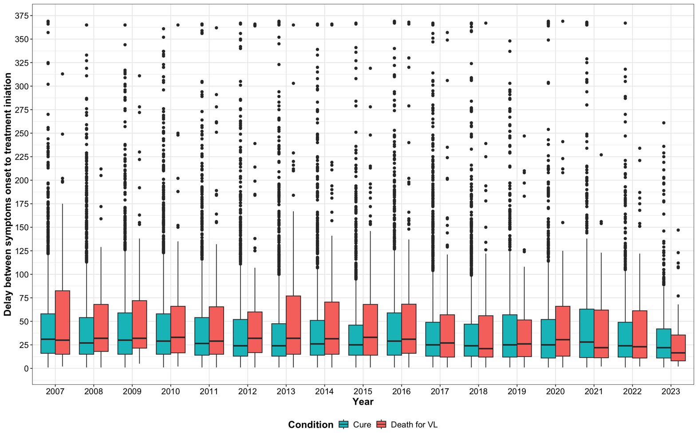
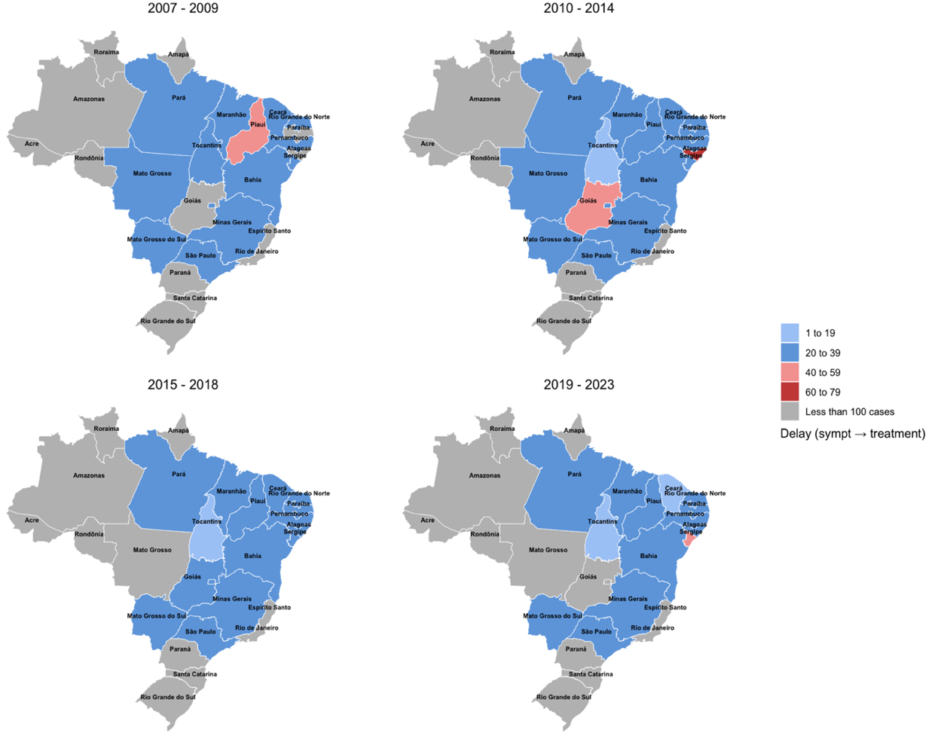
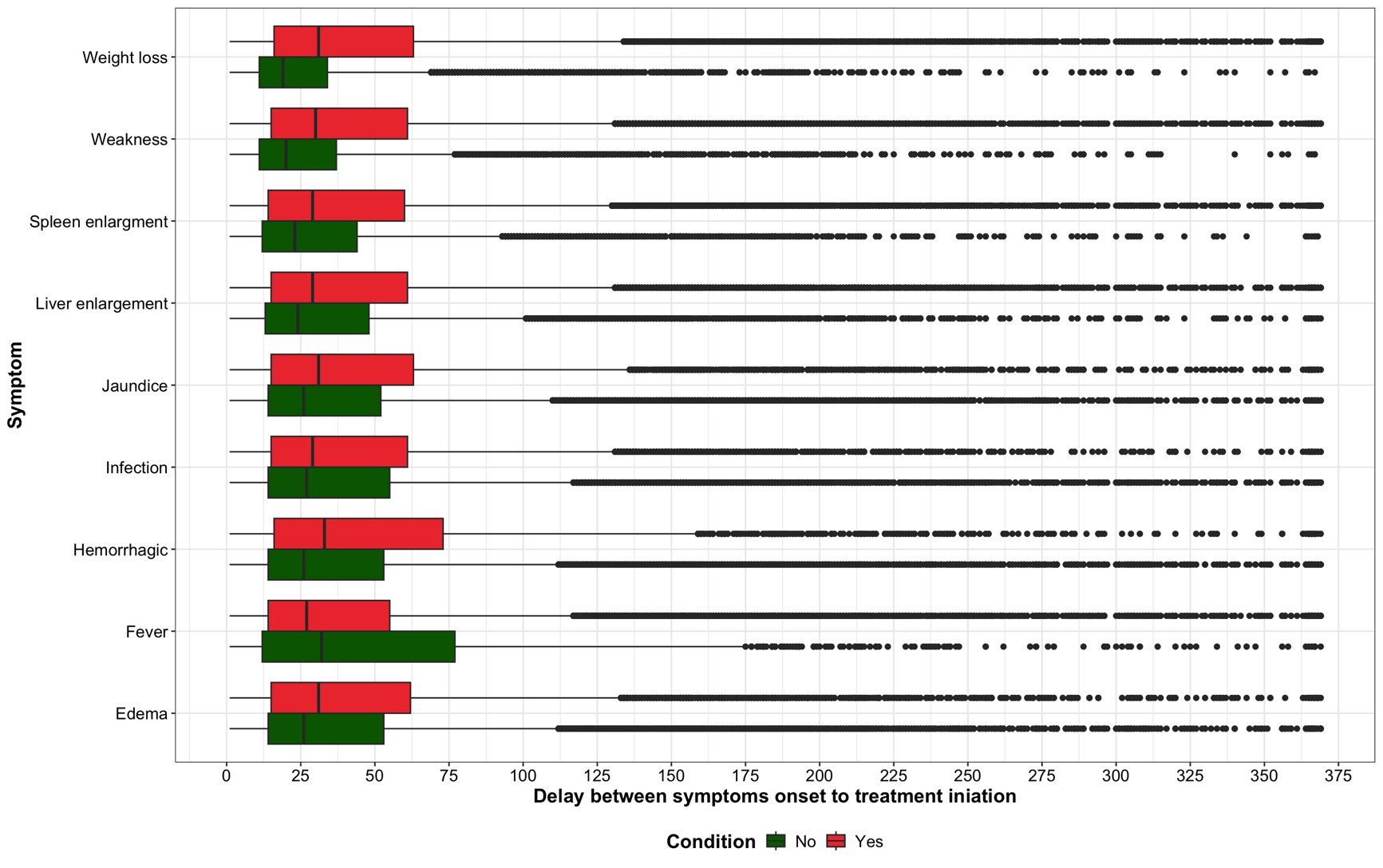
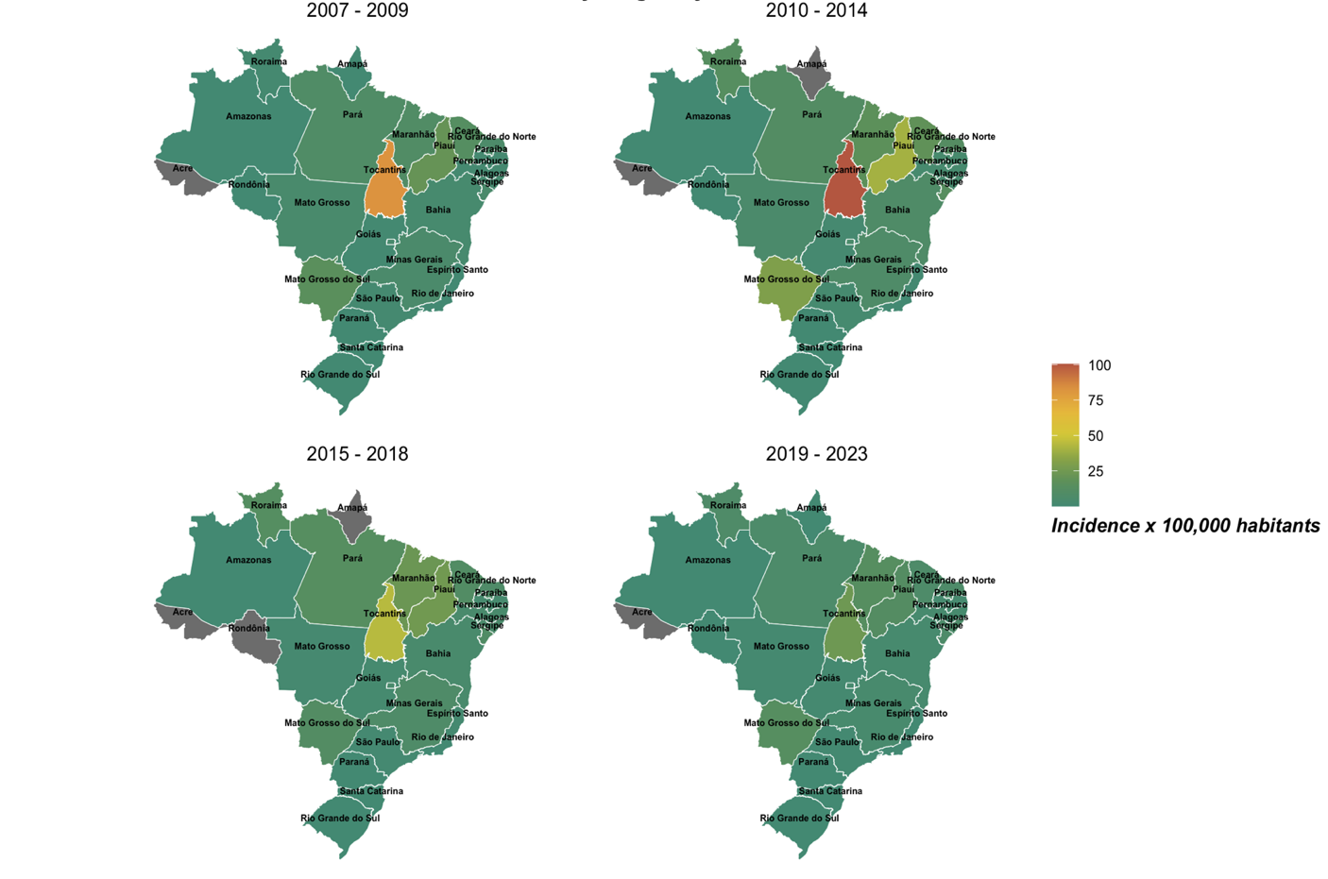
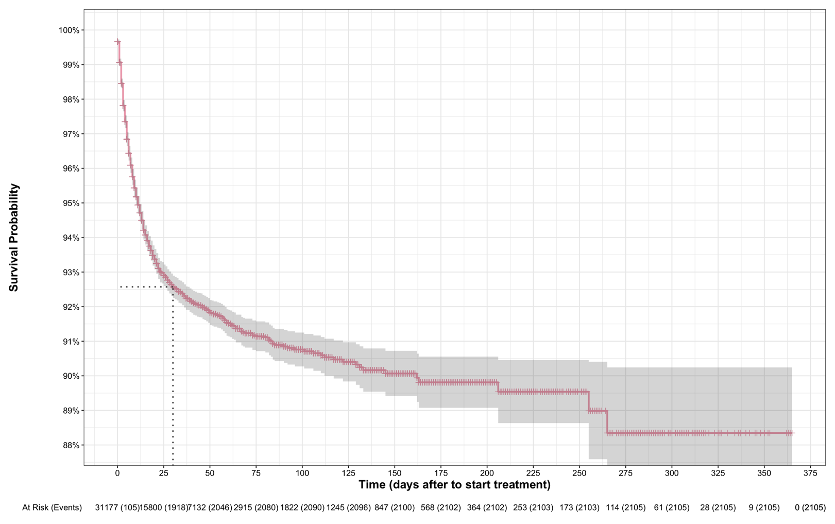
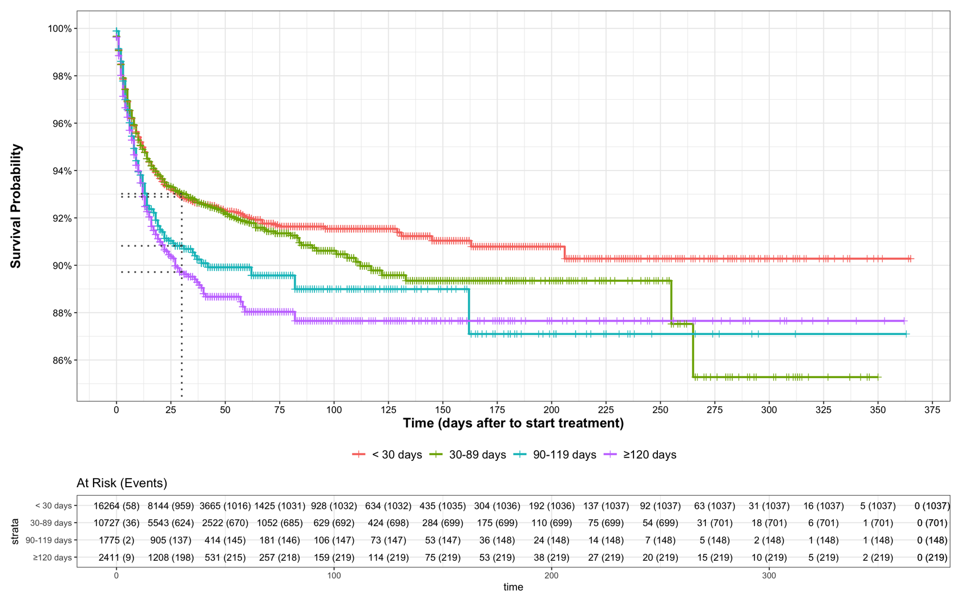
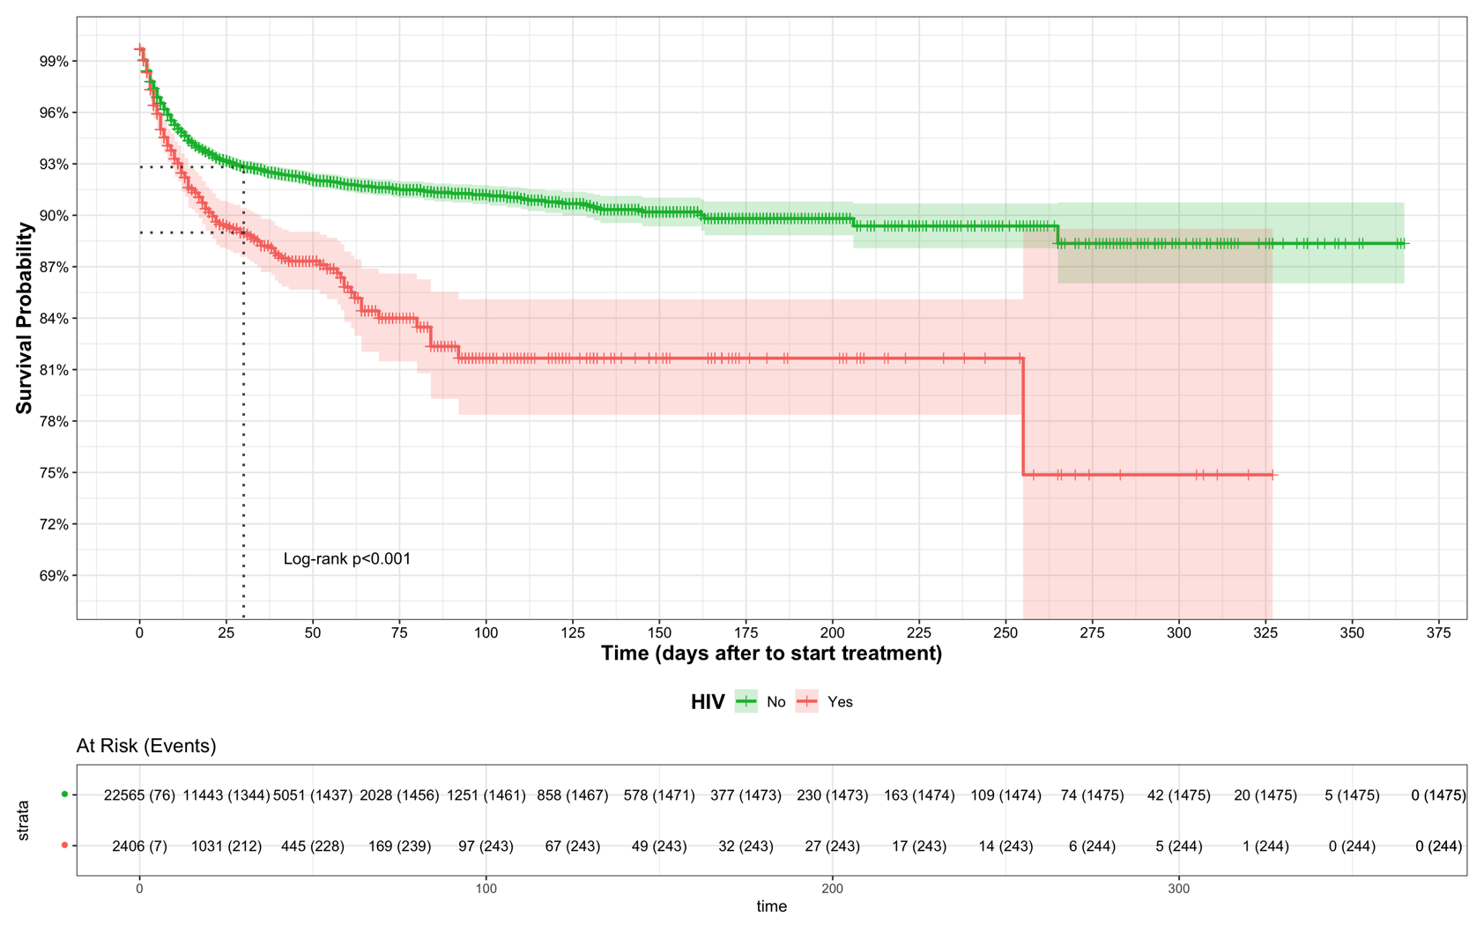

Table 1: Baseline characteristics
Characteristic | Level | n/N | Median time t_{s}-t_{d} | Range t_{s}-t_{d} | Median time t_{d}-t_{t} | Range t_{d}-t_{t} | Median time t_{s}-t_{t} | Range t_{s}-t_{t}
Age group | 0-1 | 2,386/34,928 | 16 [9-31] | 0-340 | 0 [0-2] | 0-132 | 19 [11-32] | 1-340
Age group | 1-5 | 9,330/34,928 | 18 [10-32] | 0-371 | 0 [0-2] | 0-200 | 21 [12-35] | 1-371
Age group | 6-15 | 4,907/34,928 | 20 [10-37] | 0-370 | 0 [0-2] | 0-153 | 22 [12-43] | 1-370
Age group | 16-50 | 13,210/34,928 | 31 [15-68] | 0-372 | 0 [0-3] | 0-364 | 35 [18-73] | 1-372
Age group | >50 | 5,095/34,928 | 31 [14-67] | 0-371 | 1 [0-4] | 0-149 | 34 [17-72] | 1-371
Gender | Female | 12,554/35,183 | 21 [10-41] | 0-371 | 0 [0-2] | 0-263 | 24 [13-47] | 1-372
Gender | Male | 22,629/35,183 | 28 [12-60] | 0-372 | 0 [0-3] | 0-364 | 31 [15-62] | 1-372
Period (year) | 2007-2009 | 7,134/35,186 | 27 [13-58] | 0-370 | 0 [0-3] | 0-352 | 31 [16-61] | 1-370
Period (year) | 2010-2014 | 12,102/35,186 | 24 [12-53] | 0-372 | 0 [0-3] | 0-364 | 28 [15-59] | 1-372
Period (year) | 2015-2018 | 9,856/35,186 | 23 [11-48] | 0-372 | 0 [0-3] | 0-234 | 28 [14-54] | 1-372
Period (year) | 2019-2023 | 6,094/35,186 | 24 [10-58] | 0-371 | 0 [0-2] | 0-200 | 27 [12-61] | 1-372
Region | Center-West | 2,963/35,186 | 25 [12-59] | 0-371 | 0 [0-1] | 0-149 | 27 [14-61] | 1-371
Region | North | 6,948/35,186 | 16 [8-33] | 0-370 | 2 [0-6] | 0-234 | 22 [12-41] | 1-372
Region | Northeast | 18,088/35,186 | 30 [14-61] | 0-372 | 0 [0-2] | 0-364 | 31 [15-62] | 1-372
Region | Southeast | 7,081/35,186 | 22 [12-50] | 0-371 | 1 [0-3] | 0-352 | 26 [14-56] | 1-372
Region | South | 106/35,186 | 47 [18-87] | 0-366 | 1 [0-3] | 0-69 | 54 [23-93] | 1-366
Education level | Incomplete elementary school | 3,474/26,984 | 30 [14-63] | 0-369 | 0 [0-3] | 0-364 | 33 [16-68] | 1-372
Education level | Complete elementary and incomplete middle school | 4,937/26,984 | 31 [15-68] | 0-371 | 0 [0-3] | 0-352 | 35 [18-72] | 1-372
Education level | Complete middle school and incomplete high school | 2,855/26,984 | 31 [15-62] | 0-372 | 1 [0-4] | 0-153 | 35 [18-67] | 1-372
Education level | Complete high school | 1,733/26,984 | 31 [15-65] | 0-370 | 0 [0-2] | 0-174 | 33 [17-69] | 1-372
Education level | Incomplete university | 146/26,984 | 31 [16-85] | 0-366 | 0 [0-3] | 0-91 | 33 [18-88] | 1-368
Education level | Complete university | 225/26,984 | 31 [16-63] | 0-365 | 0 [0-3] | 0-64 | 35 [21-70] | 1-366
Education level | N/A | 13,614/26,984 | 18 [10-32] | 0-371 | 0 [0-2] | 0-200 | 21 [12-35] | 1-371
Race/colour | Brown | 24,659/34,500 | 25 [11-52] | 0-371 | 0 [0-3] | 0-364 | 29 [14-58] | 1-372
Race/colour | White | 4,881/34,500 | 23 [12-50] | 0-371 | 0 [0-2] | 0-352 | 27 [14-56] | 1-371
Race/colour | Afro-descendants | 2,770/34,500 | 30 [14-64] | 0-372 | 0 [0-3] | 0-121 | 32 [16-68] | 1-372
Race/colour | Yellow | 244/34,500 | 31 [12-63] | 0-356 | 0 [0-3] | 0-70 | 36 [15-68] | 1-356
Race/colour | Indigenous | 347/34,500 | 17 [8-38] | 0-365 | 0 [0-2] | 0-73 | 22 [9-42] | 1-365
Race/colour | Unknown | 1,599/34,500 | 22 [11-48] | 0-369 | 0 [0-2] | 0-152 | 25 [13-53] | 1-371
HIV status | Unknown | 7,111/35,186 | 22 [11-49] | 0-371 | 0 [0-3] | 0-364 | 27 [14-56] | 1-372
HIV status | No | 25,394/35,186 | 24 [12-52] | 0-372 | 0 [0-3] | 0-352 | 28 [14-58] | 1-372
HIV status | Yes | 2,681/35,186 | 31 [14-64] | 0-372 | 0 [0-3] | 0-234 | 34 [17-69] | 1-372
Evolution | Cure | 26,537/31,177 | 22 [11-48] | 0-372 | 0 [0-3] | 0-263 | 27 [14-54] | 1-372
Evolution | Death for VL | 2,105/31,177 | 27 [11-61] | 0-369 | 0 [0-3] | 0-234 | 30 [14-65] | 1-371
Evolution | Death for any-cause | 529/31,177 | 29 [10-62] | 0-366 | 0 [0-3] | 0-123 | 32 [14-67] | 1-367
Evolution | Neglect | 169/31,177 | 25 [8-61] | 0-311 | 0 [0-2] | 0-70 | 32 [10-65] | 1-312
Evolution | Transferred | 1,837/31,177 | 31 [15-62] | 0-372 | 0 [0-2] | 0-364 | 32 [17-65] | 1-372

Table 3. Univariable and multivariable linear regression models, outcome is under log scale
 | Univariate |  |  | Multivariable
Characteristic | Ratio geometric means | 95% CI | p-value |  | Ratio geometric means | 95% CI | p-value
Age group
16-50 | — | — |  |  | — | —
0-1 | 0.56 | 0.53, 0.59 | <0.001 |  | 0.52 | 0.48, 0.57 | <0.001
1-5 | 0.62 | 0.61, 0.64 | <0.001 |  | 0.59 | 0.55, 0.63 | <0.001
6-15 | 0.69 | 0.67, 0.72 | <0.001 |  | 0.65 | 0.62, 0.68 | <0.001
>50 | 0.98 | 0.95, 1.02 | 0.3 |  | 1.01 | 0.96, 1.05 | 0.8
Gender
Female | — | — |  |  | — | —
Male | 1.17 | 1.14, 1.19 | <0.001 |  | 1.03 | 1.01, 1.06 | 0.011
Period
2010-2014 | — | — |  |  | — | —
2007-2009 | 1.09 | 1.06, 1.13 | <0.001 |  | 1.15 | 1.11, 1.19 | <0.001
2015-2018 | 0.94 | 0.91, 0.96 | <0.001 |  | 0.93 | 0.90, 0.96 | <0.001
2019-2023 | 0.91 | 0.88, 0.94 | <0.001 |  | 0.86 | 0.83, 0.89 | <0.001
Region
Northeast | — | — |  |  | — | —
Center-West | 0.93 | 0.89, 0.97 | <0.001 |  | 0.84 | 0.80, 0.88 | <0.001
North | 0.79 | 0.77, 0.82 | <0.001 |  | 0.79 | 0.77, 0.82 | <0.001
South | 1.54 | 1.25, 1.89 | <0.001 |  | 1.45 | 1.16, 1.82 | 0.001
Southeast | 0.94 | 0.91, 0.97 | <0.001 |  | 0.85 | 0.82, 0.88 | <0.001
Education
Complete elementary and incomplete middle school | — | — |  |  | — | —
Incomplete elementary school | 0.93 | 0.89, 0.97 | <0.001 |  | 0.97 | 0.93, 1.01 | 0.2
Complete middle school and incomplete high school | 0.97 | 0.92, 1.01 | 0.2 |  | 0.92 | 0.88, 0.96 | <0.001
Complete high school | 0.94 | 0.89, 1.00 | 0.034 |  | 0.91 | 0.86, 0.97 | 0.002
Incomplete university | 1.04 | 0.88, 1.24 | 0.6 |  | 1.00 | 0.84, 1.17 | >0.9
Complete university | 1.00 | 0.87, 1.15 | >0.9 |  | 0.97 | 0.85, 1.11 | 0.7
N/A | 0.60 | 0.58, 0.62 | <0.001 |  | 0.96 | 0.89, 1.02 | 0.2
Race
Brown | — | — |  |  | — | —
Afro-descendants | 1.18 | 1.13, 1.23 | <0.001 |  | 1.09 | 1.04, 1.14 | <0.001
Indigenous | 0.77 | 0.69, 0.86 | <0.001 |  | 0.92 | 0.82, 1.03 | 0.2
Unknown | 0.96 | 0.91, 1.02 | 0.2 |  | 0.94 | 0.87, 1.01 | 0.10
White | 1.02 | 0.98, 1.05 | 0.3 |  | 1.00 | 0.97, 1.04 | >0.9
Yellow | 1.17 | 1.02, 1.34 | 0.027 |  | 1.16 | 1.00, 1.34 | 0.052
HIV status
No | — | — |  |  | — | —
Yes | 1.17 | 1.12, 1.23 | <0.001 |  | 0.99 | 0.94, 1.04 | 0.7
Unknown | 0.98 | 0.96, 1.01 | 0.2 |  | 1.01 | 0.98, 1.04 | 0.6

Table 2.
Characteristic | Cure  median [range] days (t_{t}–t_{c})¹ | Death  median [range] days (t_{t}–t_{m})¹ | Overall  median [range] days (t_{t}–t_{o})¹
Age group
0-1 | 26 [1-342] | 7 [1-163] | 23 [1-342]
1-5 | 28 [1-353] | 6 [1-206] | 26 [1-354]
16-50 | 28 [1-365] | 7 [1-265] | 26 [1-365]
6-15 | 28 [1-363] | 6 [1-133] | 27 [1-363]
>50 | 23 [1-365] | 7 [1-131] | 19 [1-365]
Gender
Female | 27 [1-365] | 7 [1-206] | 25 [1-365]
Male | 27 [1-365] | 7 [1-265] | 25 [1-365]
Region
Center-West | 27 [1-363] | 7 [1-255] | 24 [1-363]
North | 32 [1-365] | 7 [1-265] | 30 [1-365]
Northeast | 26 [1-364] | 7 [1-206] | 24 [1-364]
South | 14 [1-196] | 4 [2-129] | 12 [1-196]
Southeast | 25 [1-350] | 7 [1-110] | 22 [1-362]
Race/colour
Afro-descendants | 28 [1-365] | 5 [1-206] | 26 [1-365]
Brown | 28 [1-365] | 7 [1-265] | 25 [1-365]
Indigenous | 24 [1-302] | 7 [1-22] | 20 [1-302]
Unknown | 24 [1-364] | 5 [1-129] | 21 [1-364]
White | 26 [1-314] | 7 [1-162] | 24 [1-362]
Yellow | 28 [1-327] | 8 [2-20] | 25 [1-327]
Signs and Symptoms
Fever | 27 [1-365] | 7 [1-265] | 25 [1-365]
Oedema | 28 [1-363] | 6 [1-206] | 24 [1-363]
Weight loss | 28 [1-365] | 7 [1-265] | 26 [1-365]
Cough and dyspnoea | 28 [1-365] | 7 [1-255] | 25 [1-365]
Splenomegaly | 28 [1-365] | 7 [1-255] | 25 [1-365]
Haemorrhage | 26 [1-363] | 6 [1-206] | 21 [1-363]
Hepatomegaly | 27 [1-365] | 7 [1-255] | 25 [1-365]
Jaundice | 28 [1-365] | 6 [1-206] | 25 [1-365]
HIV status
No | 27 [1-365] | 7 [1-265] | 25 [1-365]
Yes | 23 [1-327] | 8 [1-255] | 21 [1-362]
Treatment
Amphotericin B deoxycholate | 24 [1-342] | 6 [1-206] | 21 [1-342]
Antimonial Pentavalent | 31 [1-364] | 9 [1-163] | 29 [1-364]
Liposomal amphotericin B | 18 [1-365] | 6 [1-265] | 16 [1-365]
Others | 29 [1-317] | 8 [1-29] | 24 [1-317]
¹Time between treatment initiation (t_{t}) and outcome
t_{c} = time to cure, t_{m} = time to death, t_{o} = time to outcome

Characteristic | Cure  N = 26,333¹ | Death for VL  N = 2,089¹ | Overall  N = 28,422¹ | p-value²
age_group_2 |  |  |  | <0.001
0-1 | 1,771 (6.7%) | 181 (8.7%) | 1,952 (6.9%)
1-5 | 7,309 (28%) | 263 (13%) | 7,572 (27%)
6-15 | 3,904 (15%) | 72 (3.4%) | 3,976 (14%)
16-50 | 9,921 (38%) | 764 (37%) | 10,685 (38%)
>50 | 3,428 (13%) | 809 (39%) | 4,237 (15%)
Gender |  |  |  | 0.13
Female | 9,486 (36%) | 718 (34%) | 10,204 (36%)
Male | 16,845 (64%) | 1,371 (66%) | 18,216 (64%)
Race/Colour |  |  |  | <0.001
Afro-descendants | 2,097 (8.1%) | 198 (9.6%) | 2,295 (8.2%)
Brown | 18,183 (70%) | 1,345 (66%) | 19,528 (70%)
Indigenous | 243 (0.9%) | 32 (1.6%) | 275 (1.0%)
Unknown | 1,219 (4.7%) | 141 (6.9%) | 1,360 (4.9%)
White | 3,881 (15%) | 318 (15%) | 4,199 (15%)
Yellow | 189 (0.7%) | 18 (0.9%) | 207 (0.7%)
Period |  |  |  | <0.001
2007-2009 | 5,432 (21%) | 323 (16%) | 5,755 (20%)
2010-2014 | 9,110 (35%) | 659 (32%) | 9,769 (35%)
2015-2018 | 7,369 (28%) | 642 (31%) | 8,011 (28%)
2019-2023 | 4,284 (16%) | 453 (22%) | 4,737 (17%)
Region |  |  |  | <0.001
Centre-West | 2,363 (9.0%) | 236 (11%) | 2,599 (9.1%)
North | 5,562 (21%) | 274 (13%) | 5,836 (21%)
Northeast | 12,464 (47%) | 1,017 (49%) | 13,481 (47%)
South | 81 (0.3%) | 12 (0.6%) | 93 (0.3%)
Southeast | 5,863 (22%) | 550 (26%) | 6,413 (23%)
HIV |  |  |  | <0.001
No | 19,254 (73%) | 1,464 (70%) | 20,718 (73%)
Yes | 1,830 (6.9%) | 243 (12%) | 2,073 (7.3%)
Unknown | 5,249 (20%) | 382 (18%) | 5,631 (20%)
Days symptoms to treatment | 27 (14,54) | 30 (14,65) | 27 (14,55) | <0.001
Treatment |  |  |  | <0.001
Amphotericin B deoxycholate | 3,054 (12%) | 489 (23%) | 3,543 (12%)
Antimonial Pentavalent | 16,468 (63%) | 696 (33%) | 17,164 (60%)
Liposomal amphotericin B | 6,058 (23%) | 861 (41%) | 6,919 (24%)
Others | 753 (2.9%) | 43 (2.1%) | 796 (2.8%)
¹n (%); Median (Q1,Q3)
²Pearson's Chi-squared test; Wilcoxon rank sum test

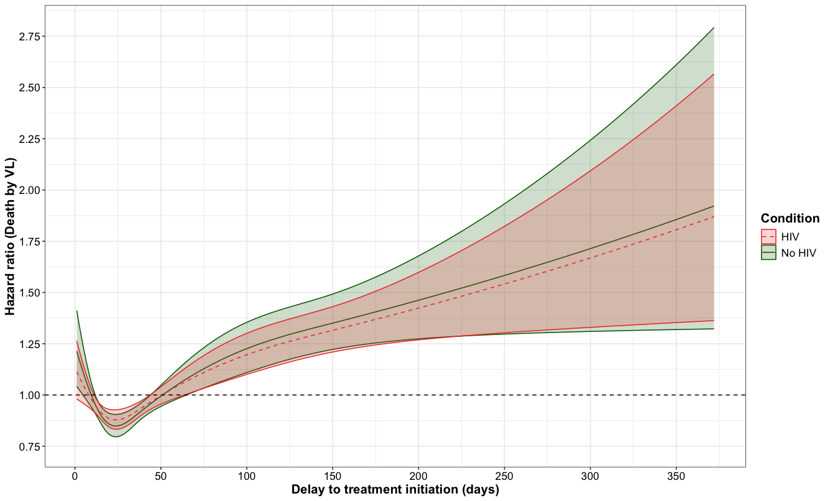
Fig xxx. Evaluation for severe symptoms and delay in treatment initiation according to HIV status and overall. a) No HIV, b) HIV, c) Overall

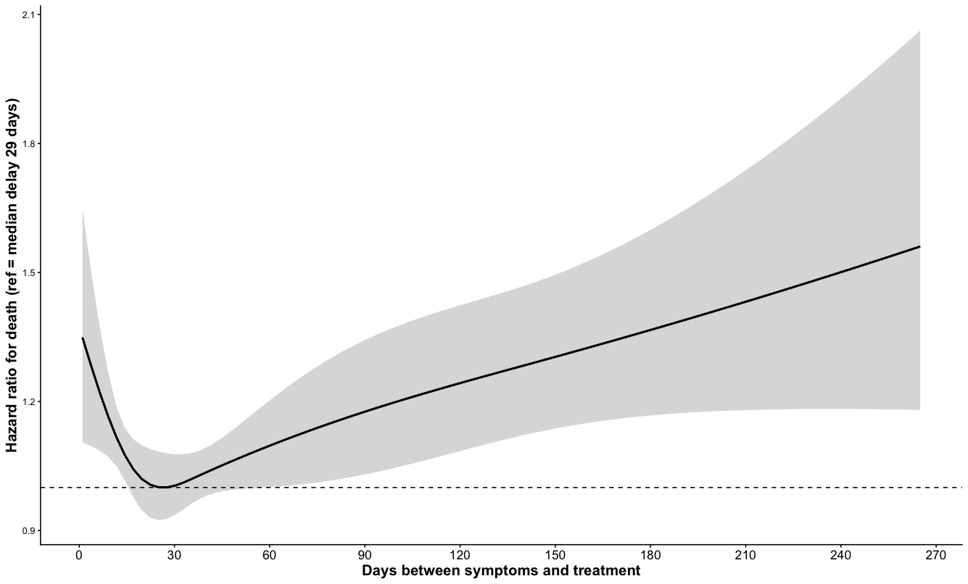
Fig xxx. Adjusted by gender, age, no HIV, education level, race/colour and region.

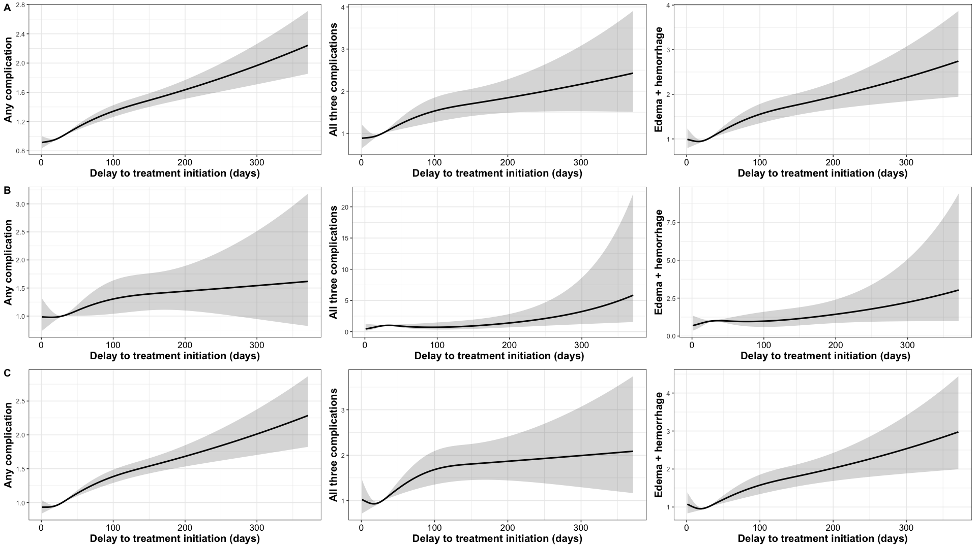
Fig xxx. Evaluation of the odds ratio according to the presence of symptoms for all of them (jaundice, oedema and haemorrhage), some of them and just Oedema and haemorrhage, and the relationship with delay in treatment initiation in the HIV population.

Supplementary
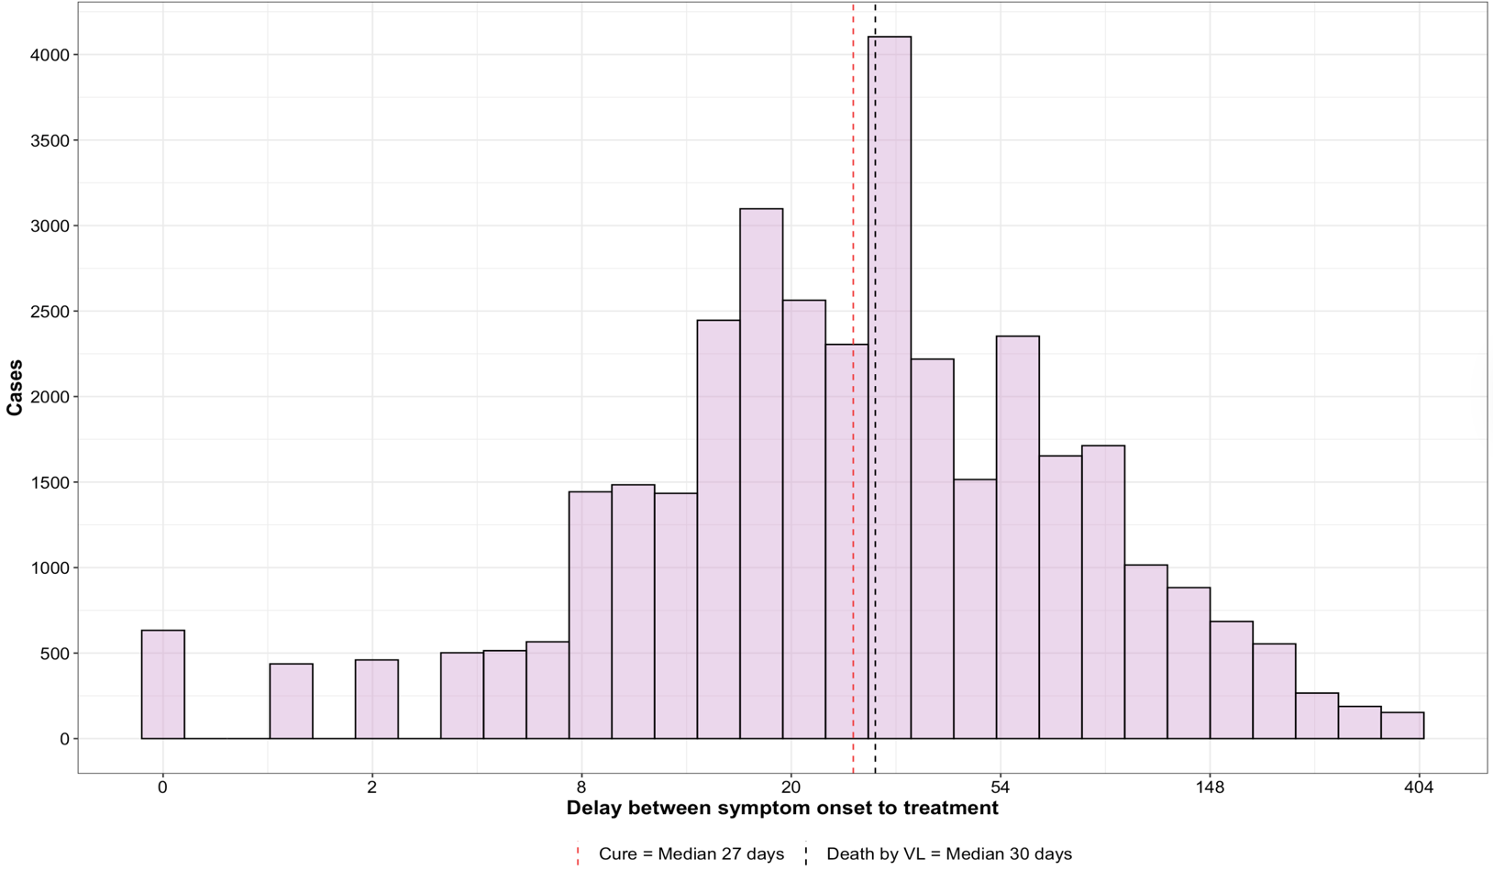
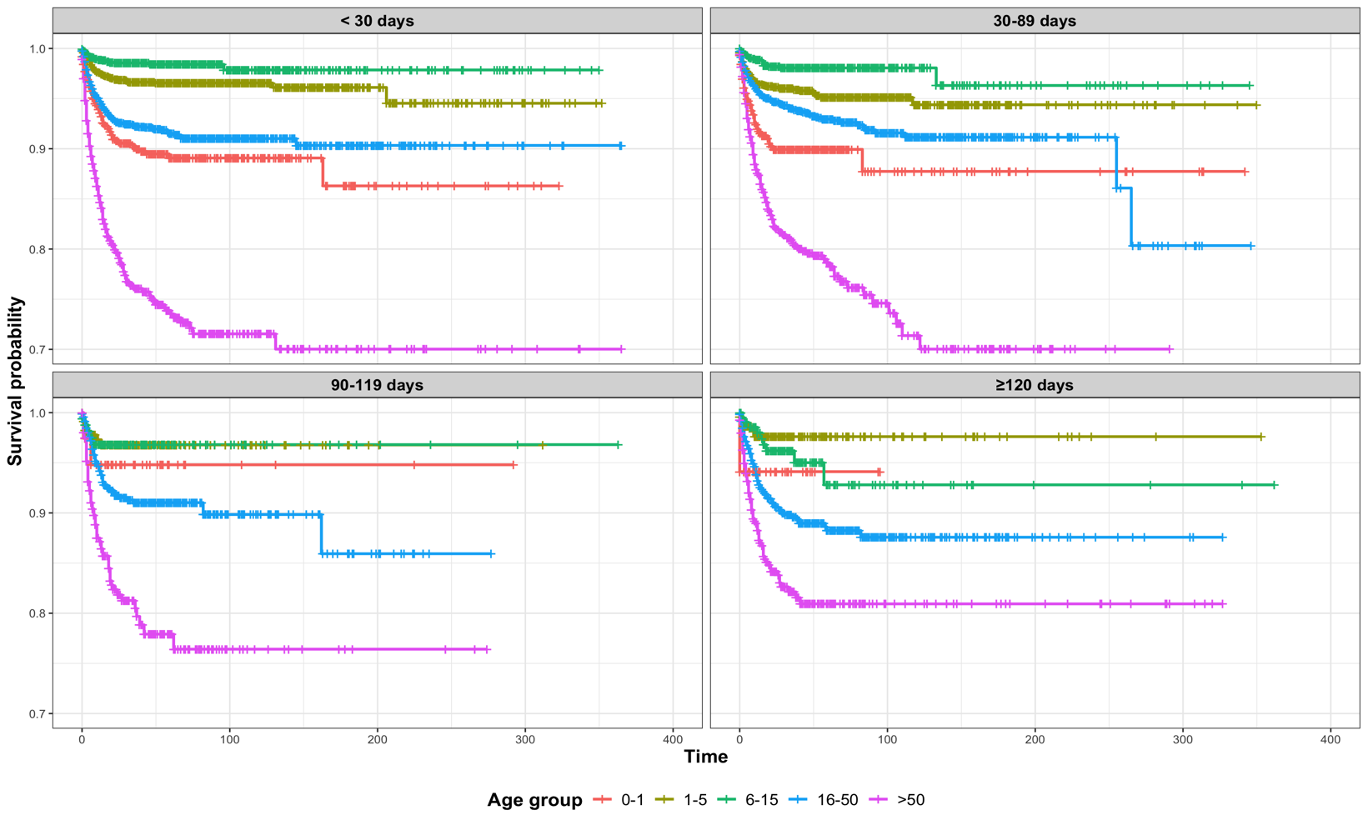
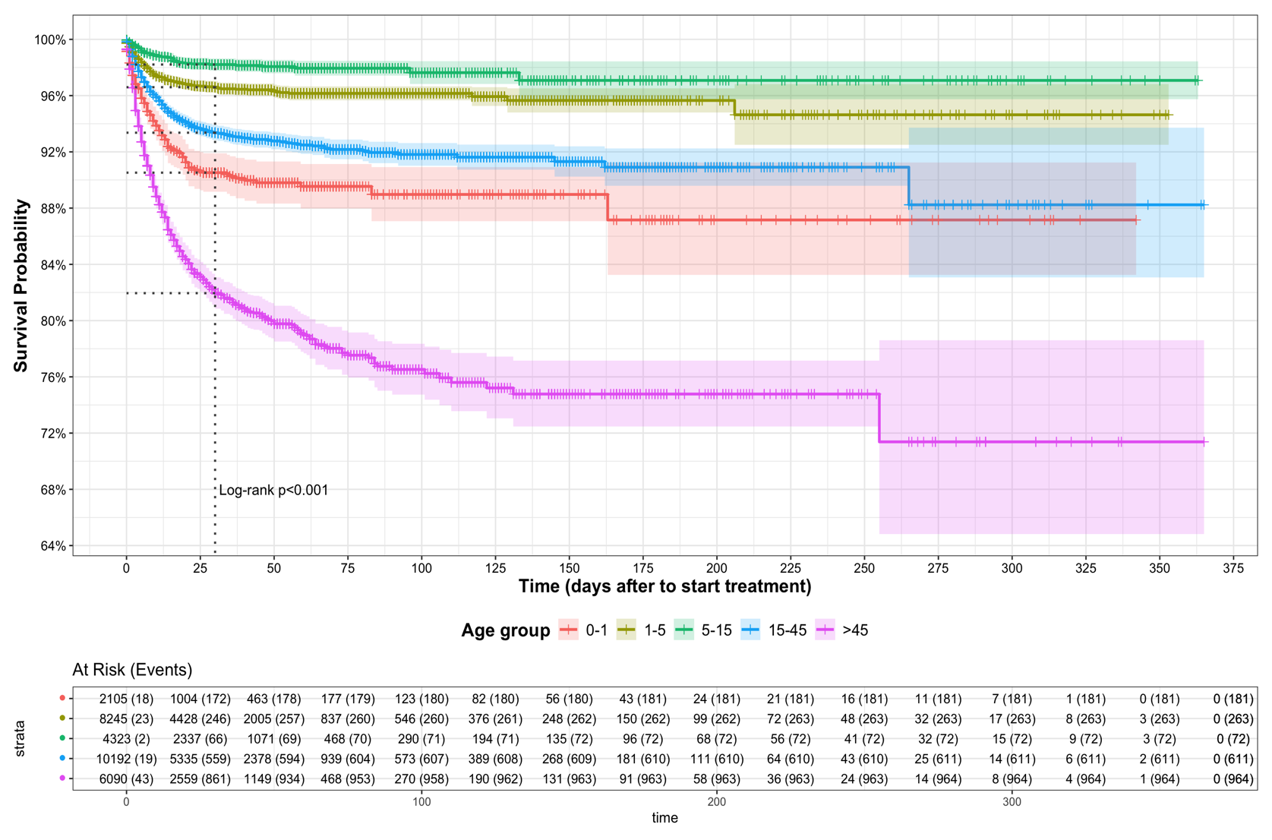
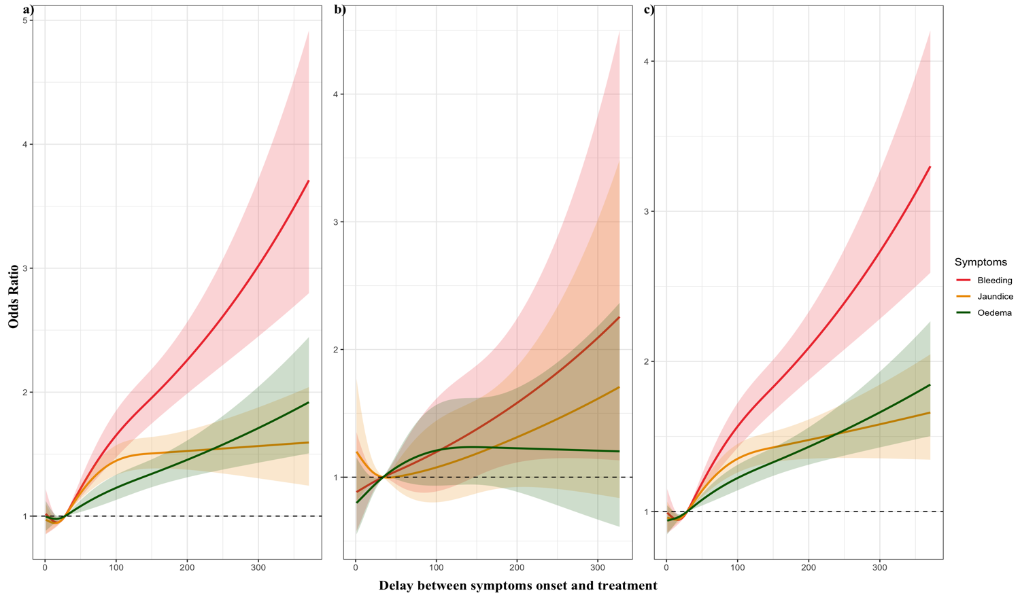
Fig xxx. Evaluation of the odds ratio for severe symptoms and delay in treatment initiation according to HIV status and overall. a) No HIV, b) HIV, c) Overall

